Insert your centre number, name and candidate number into the header above.
Save this evidence document as evidence_ followed by your centre number_ candidate number. For example: evidence_ zz999_9999
Screenshots or program listings must be copied into appropriate cells in the following table.
Examiners must be able to read the contents including any screenshots without the use of a magnifying glass. Answers that are not readable or missing will not be awarded any marks.
Save this evidence document at regular intervals, for example every 10 minutes.
Question 1
Part 1(a)
player_data = [["", ""] for _ in range(11)]

Part 1(b)
def ReadHighScores():
with open("2022/May June/p41/HighScore.txt", "r") as file:
content = file.read()
content = content.split("\n")
players = []
scores = []
for i in range(len(content)):
if i % 2 == 0:
players.append(content[i])
elif i % 2 == 1:
scores.append(content[i])
for i in range(len(players)):
player_data[i][0] = players[i]
player_data[i][1] = scores[i]

Part 1(c)
def OutputHighScores():
for player, score in player_data:
print(f"{player} {score}")

Part 1(d)(i)
ReadHighScores()
OutputHighScores()

Part 1(d)(ii)
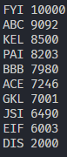

Part 1(e)(i)
player_name = ""
int_score = -1

while len(player_name) != 3:
player_name = input("Input a 3 character player name: ")

while int_score < 1 or int_score > 100000:
int_score = int(input("Enter an integer score that is between 1 and 100,000 inclusive: "))

Part 1(e)(ii)
def InsertPlayer(player, score):
global player_data
for i in range(10):
if score >= int(player_data[i][1]):
player_data.insert(i, [player,str(score)])
break
player_data = player_data[:10]

Part 1(e)(iii)
InsertPlayer(player_name, int_score)

OutputHighScores()

Part 1(e)(iv)
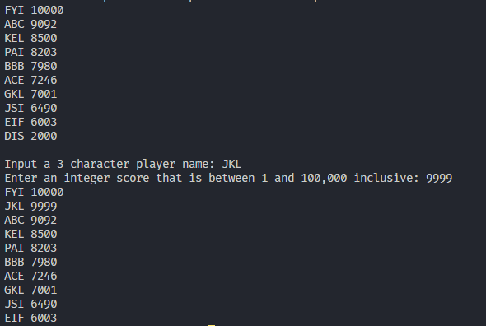

Part 1(f)
def WriteTopTen():
global player_data
try:
with open("/2022/May June/p41/NewHighScore.text", "w") as file:
content = ''
for player in player_data:
content += f"{player[0]}\n{player[1]}"
file.write(content)
file.close()
except Exception as Error:
print(f"An error occured, Traceback: {Error}")

Question 2
Part 2(a)
class Balloon:
def __init__(self, defence_item, color):
# DECLARE __health: INTEGER
# DECLARE __defence_item: STRING
# DECLARE __color: STRING
self.__health = 100
self.__defence_item = defence_item
self.__color = color

Part 2(b)
def GetDefenceItem(self):
return self.__defence_item

Part 2(c)
def ChangeHealth(self, change:int):
self.__health += change

Part 2(d)
def CheckHealth(self):
if self.__health <= 0:
return True
else:
return False

Part 2(e)
defence_item = input("Enter defence item for balloon to use: ")
color = input("Enter color of the balloon: ")

Balloon1 = Balloon(defence_item, color)

Part 2(f)
def Defend(balloon:Balloon):
strength = input("Opponent Strength: ")
balloon.ChangeHealth(-int(strength))
print(balloon.GetDefenceItem())
has_no_heath = balloon.CheckHealth()
if not has_no_heath:
print("Balloon still has health!")
else:
print("Balloon has no heath left :(")
return balloon

Part 2(g)(i)
Defend(Balloon1)

Part 2(g)(ii)
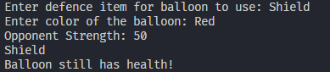

Question 3
Part 3(a)
# DECLARE QueueArray: ARRAY[0:9] OF STRING
QueueArray = ["" for _ in range(10)]
head = 0
tail = 0
number_of_items = 0

Part 3(b)
def Enqueue(DataToAdd) -> bool:
global number_of_items, head, tail, QueueArray
if number_of_items == 10:
return False
QueueArray[tail] = DataToAdd
if tail >= 9:
tail = 0
else:
tail = tail + 1
number_of_items = number_of_items + 1
return True

Part 3(c)
def Dequeue():
global QueueArray, head, tail, number_of_items
if number_of_items <= 0:
return "FALSE"

return_element = QueueArray[head]
if head >= 9:
head = 0
else:
head = head +1
number_of_items = number_of_items - 1
return return_element

Part 3(d)(i)
for _ in range(11):
value = input("Enter a string value: ")
res = Enqueue(value)
if res:
print(f"{value} was added successfully to the queue")
else:
print(f"{value} could not be added to the queue")

print(Dequeue())
print(Dequeue())

Part 3(d)(ii)
